MICROPHONE

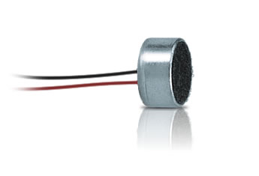

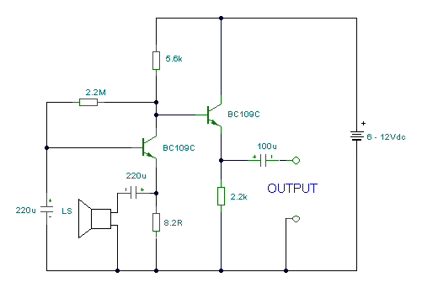

Microphone Characteristics:

There are three main considerations when choosing a microphone for recording applications: operating principle, frequency response, and directionality.

Operating Principle :

A microphone is an example of a transducer, a device which changes energy from one form into another, in this case from acoustic into electrical. The type of transducer is defined by the operating principle. In the current era of recording, the two primary operating principles used in microphone design are the dynamic and the condenser.
Dynamic microphone elements:

Are made up of a diaphragm, voice coil, and magnet which form a sound-driven electrical generator. Sound waves move the diaphragm/voice coil in a magnetic field to generate the electrical equivalent of the acoustic sound wave. The signal from the dynamic element can be used directly, without the need for additional circuitry. This design is extremely rugged, has good sensitivity and can handle the loudest possible sound pressure levels without distortion. The dynamic has some limitations at extreme high and low frequencies. To compensate, small resonant chambers are often used to extend the frequency range of dynamic microphones.

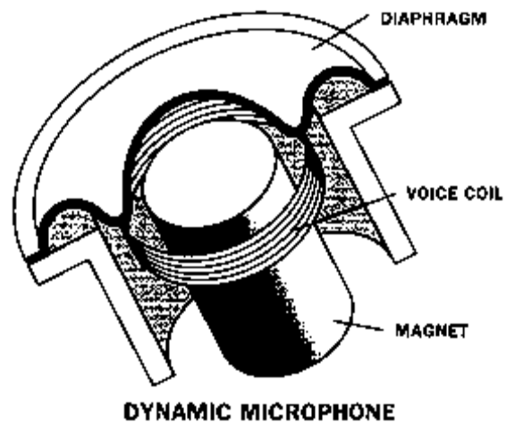
Ribbon microphone elements:

A variation of the dynamic microphone operating principle, consist of a thin piece of metal, typically corrugated aluminum, suspended between two magnetic pole pieces. As with moving-coil dynamics, no additional circuitry or powering is necessary for operation, however, the output of ribbon microphones tends to be quite low. Depending on the gain of the mixer or recording device to which the microphone is connected, additional pre-amplification may be necessary. Note that ribbon microphones are not as rugged as moving-coil dynamic microphones. The ribbon element itself is typically no more than a few microns thick, and can be deformed by a strong blast of air, or by blowing into the microphone. Also, phantom power applied to the ribbon microphone could be harmful. Ribbon microphones are highly regarded in studio recording for their “warmth” and good low frequency response

Condenser microphone elements :

use a conductive diaphragm and an electrically charged backplate to form a sound-sensitive “condenser” (capacitor). Sound waves move the diaphragm in an electric field to create the electrical signal. In order to use this signal from the element, all condensers have active electronic circuitry, (often referred to as the “preamp”) either built into the microphone or in a separate pack. This means that condenser microphones require phantom power or a battery to operate. (For a detailed explanation of “phantom power”, see the sidebar.) However, the condenser design allows for smaller mice elements, higher sensitivity and is inherently capable of smooth response across a very wide frequency range. The main limitations of a condenser microphone relate to its electronics. These circuits can handle a specified maximum signal level from the condenser element, so a condenser mic has a maximum sound level before its output starts to be distorted. Some condensers have switchable pads or attenuators between the element and
the electronics to allow them to handle higher sound levels. If you hear distortion when using a condenser microphone close to a very loud sound source, first make sure that the mixer input itself is not being overloaded. If not, switch in the attenuator in the mic (if equipped), move the mice farther away, or use a mice that can handle a higher level. In any case, the microphone will not be damaged by excess level. A second side effect of the condenser/electronics design is that it generates a certain amount of electrical noise (self-noise) which may be heard as “hiss” when recording very quiet sources at high gain settings. Higher quality condenser mics have very low self-noise, a desirable characteristic for this type of recording application. Most modern condenser microphones use solid state components for the internal circuitry, but older designs employed vacuum tubes (also known as “valves”) for this purpose. The subjective qualities imparted by vacuum

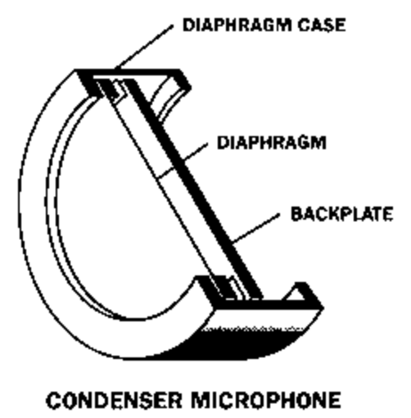

tube electronics, often described as “warmth” or “smoothness,” have led to a resurgence in the popularity of vacuum tube-based condenser microphones. These sonic advantages come at the expense of higher self-noise and fragility. Vacuum tubes typically have a limited life span, and eventually need to be replaced. Most vacuum tube microphones require an external power supply, as standard 48V phantom power is not sufficient. Some power supplies offer the ability to switch polar patterns remotely on microphones that feature dual-diaphragms (see Directionality for a discussion of microphone polar patterns).
Acoustic Characteristics:

Since room acoustics have been mentioned repeatedly, here is a brief introduction to some basic factors involved in acoustics.

Sound Waves :

Sound waves consist of pressure variations traveling through the air. When the sound wave travels, it compresses air molecules together at one point. This is called the high pressure zone or positive component(+). After the compression, an expansion of molecules occurs. This is the low pressure zone or negative component(-). This process continues along the path of the sound wave until its energy becomes too weak to hear. If you could view the sound wave of a pure tone traveling through air, it would appear as a smooth, regular variation of pressure that could be drawn as a sine wave. The diagram shows the relationship of the air molecules and a sine wave.

Frequency, Wavelength, and the Speed of Sound :

The frequency of a sound wave indicates the rate of pressure variations or cycles. One cycle is a change from high pressure to low pressure and back to high pressure. The number of cycles per second is called Hertz, abbreviated “Hz.” So, a 1,000Hz tone has 1,000 cycles per second. The wavelength of a sound is the physical distance from the start of one cycle to the start of the next cycle. Wavelength is related to frequency by the speed of sound. The speed of sound in air is 1130 feet per second or 344 meters/second. The speed of sound is constant no matter what the frequency. You can determine the wavelength of a sound wave of any frequency if you understand these relationships:

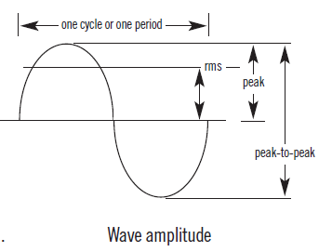
Loudness :

The fluctuation of air pressure created by sound is a change above and below normal Atmospheric pressure. This is what the human ear responds to. The varying amount of pressure of the air molecules compressing and expanding is related to the apparent loudness at the human ear. The greater the pressure change, the louder the sound. Under ideal conditions the human ear can sense a pressure change as small as .0002 microbar. One microbar is equal to one millionth of atmospheric pressure.
The threshold of pain is about 200 microbar. Obviously, the human ear responds to a wide range of amplitude of sound. This amplitude range is more commonly referred to in decibels. Sound Pressure Level (dB SPL), relative to .0002 microbar (0dB SPL). 0 dB SPL is the threshold of hearing and 120 dB SPL is the threshold of pain. 1 dB is about the smallest change in SPL that can be heard. A 3 dB change is generally noticeable, while a 6 dB change is very noticeable. A 10 dB SPL increase is perceived to be twice as loud!

